Week 3 Quiz
primary consumers ocean freshwater kelp

For questions 1-4, fill in the blank with the correct word from the word bank.
1. kelp are large brown seaweeds in the ocean.
2. Water that you can drink is called freshwater
3. Animals that only eat plants are called primary consumers
4. A large body of salty water is called ocean
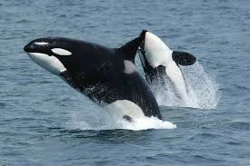
5. Circle the picture of a tertiary consumer
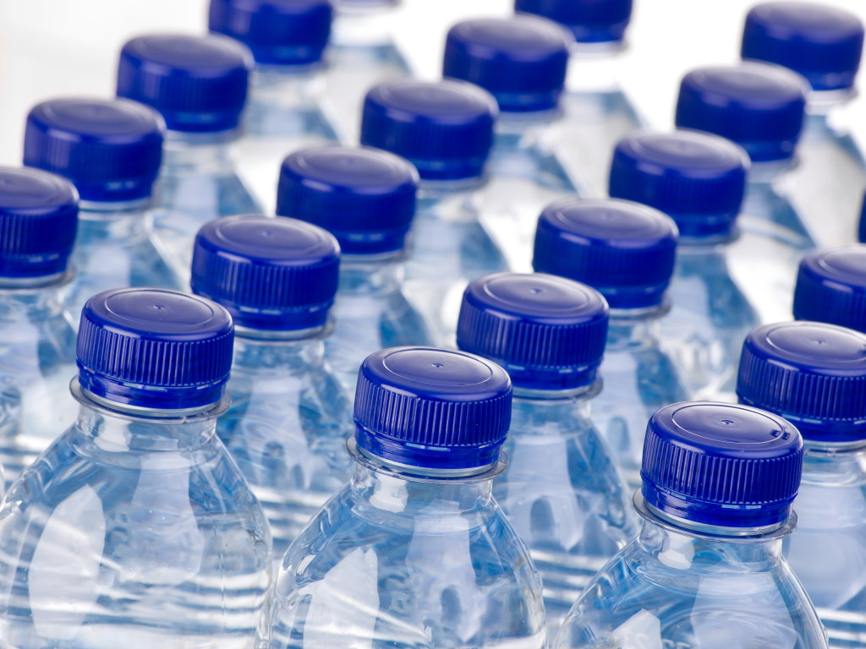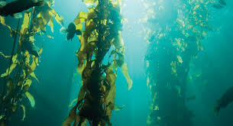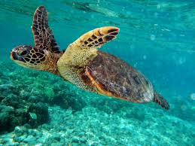
6. Is Earth getting hotter or colder during global warming? hotter
For questions 7-9, write whether the animal is a primary consumer, secondary consumer, or tertiary consumer.
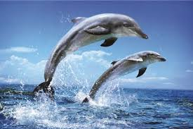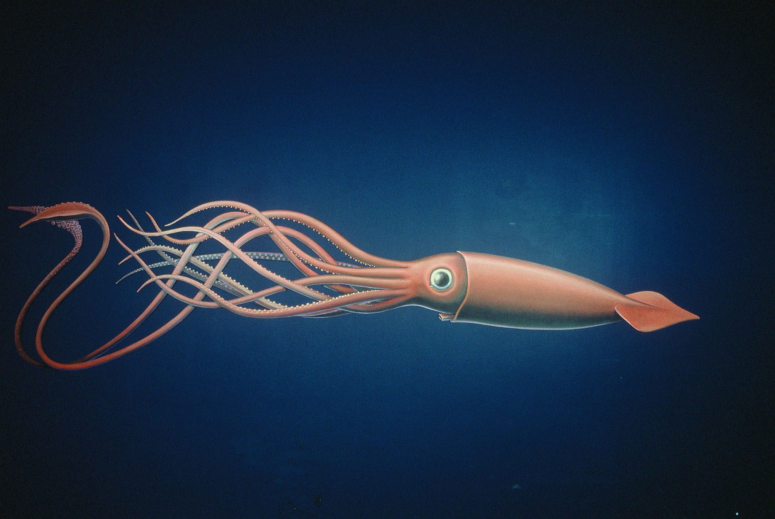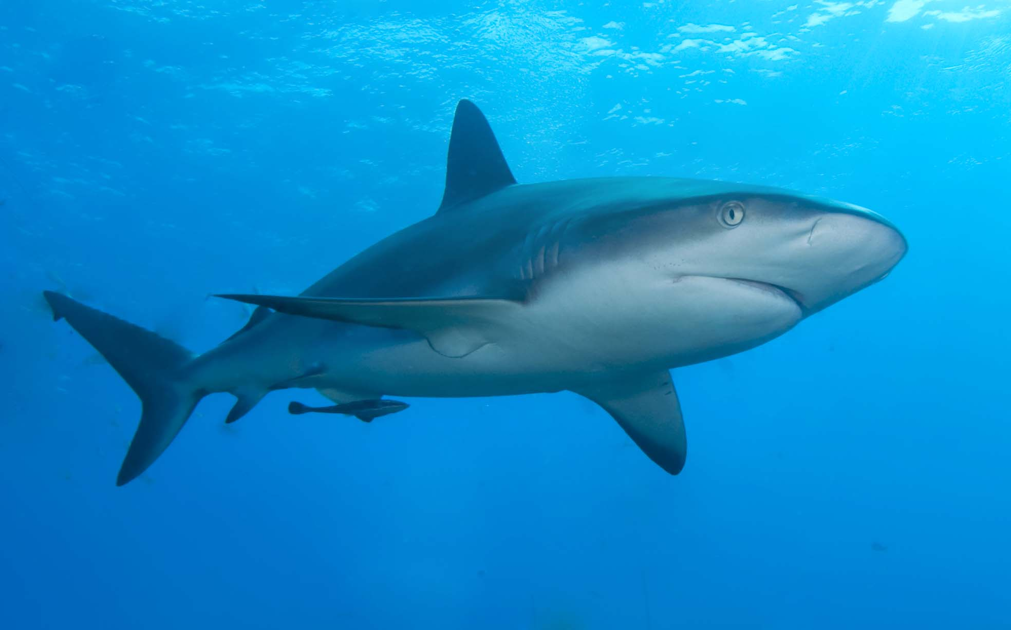
7. secondary consumer 8. primary consumer 9. tertiary consumer
10. True or False, water pollution is bad and can make fish and humans sick. True
BONUS: In the Goldfish Lab, how do humans kill fish? Circle the correct letter.
a. overfishing b. dancing c. screaming d. swimming

