Week 3 Quiz- Teacher Key
1. What do we use to measure how hot it is?
a) thermometer b) ruler
2. Which one is warmer under the sun?
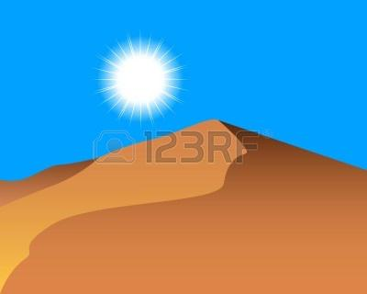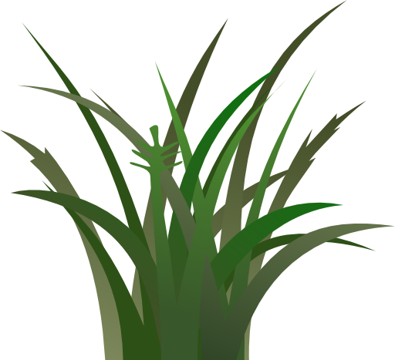
a) sand b) grass
3. What does this thermometer say?
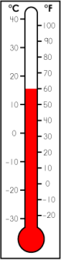 Answer: ___15/60___

4. Is it better to stand in the sun or in the shade on a hot day?

a) sun b) shade

5. Does a piece of wet paper towel dry faster outside or inside?
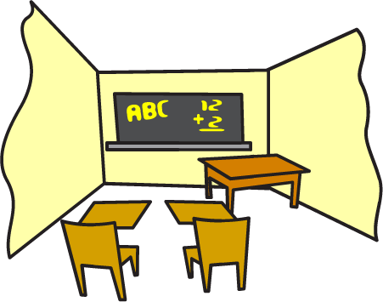
a) outside b) inside

