Hot vs. Cold!
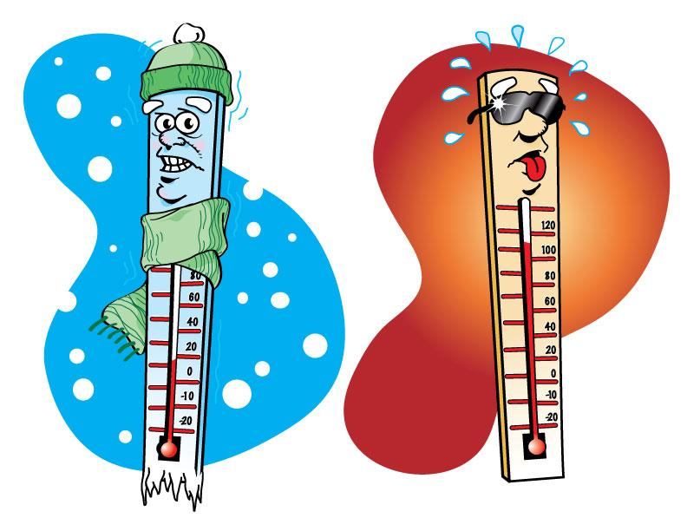

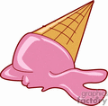
When it is hot outside the temperature rises,
When it is cold outside the temperature decreases.
When it is hot you would sweat,
When it is cold you would shiver.
When things are hot they can melt,
When things are cold they can freeze, brrr!!
Let’s us see if you know what is hot and what is cold!

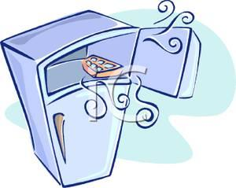

Name:__________________ Date:________

1) What can melt under the sun?
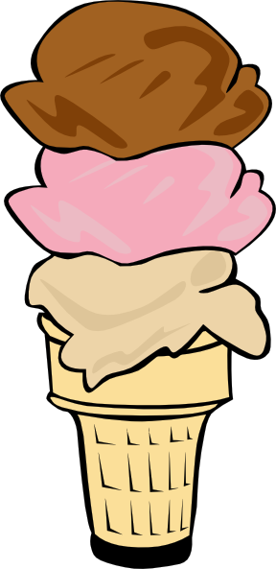

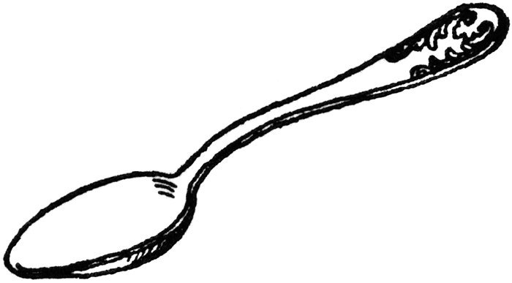

Ice Cream Spoon

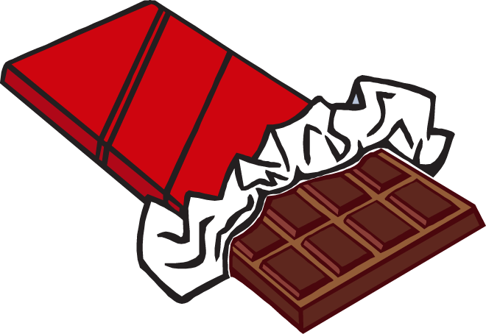
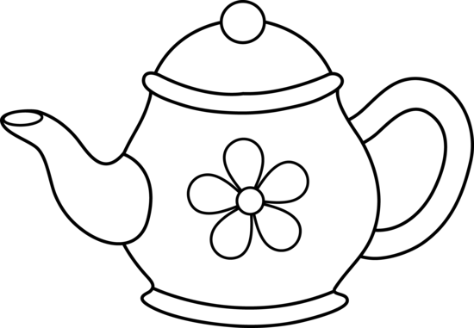

Teapot Chocolate Bar

2) What can freeze in cold temperature?

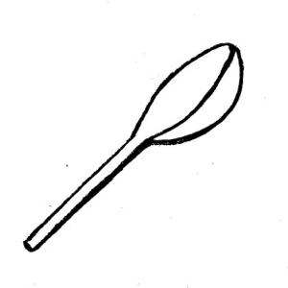
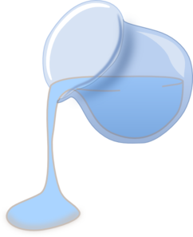

Water Spoon

3) Which one has high, medium, and low temperature?

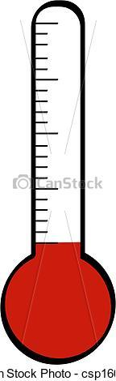
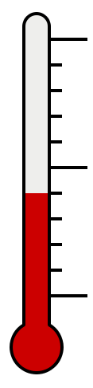

________ ________ ________

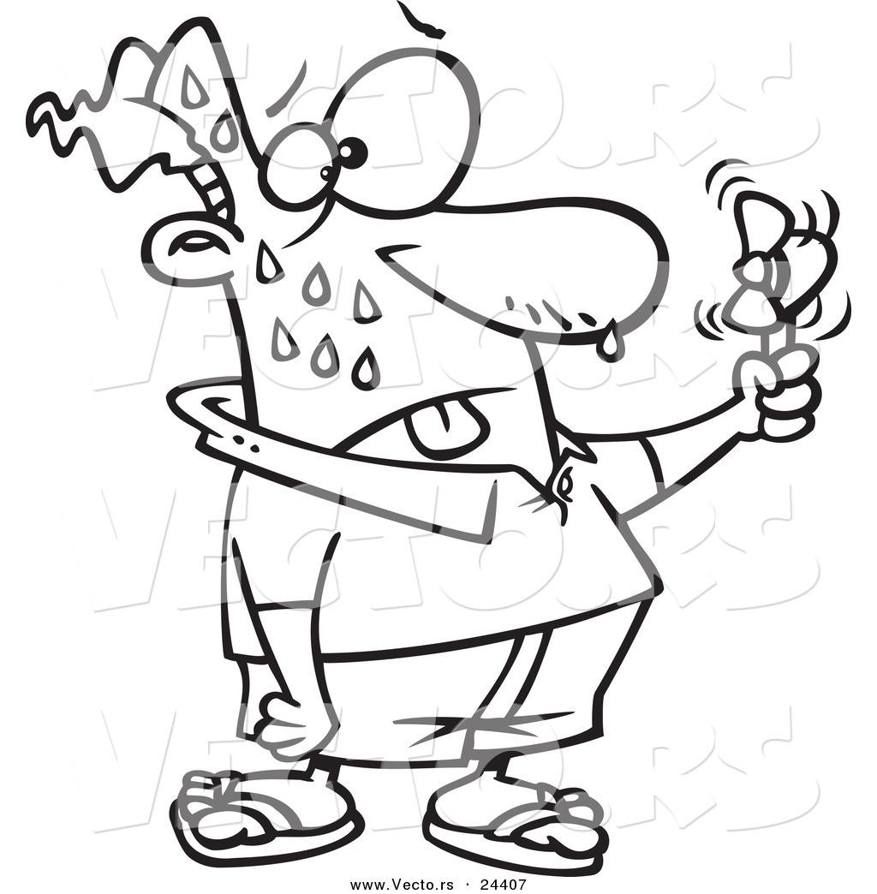
4) What happens when you are hot?

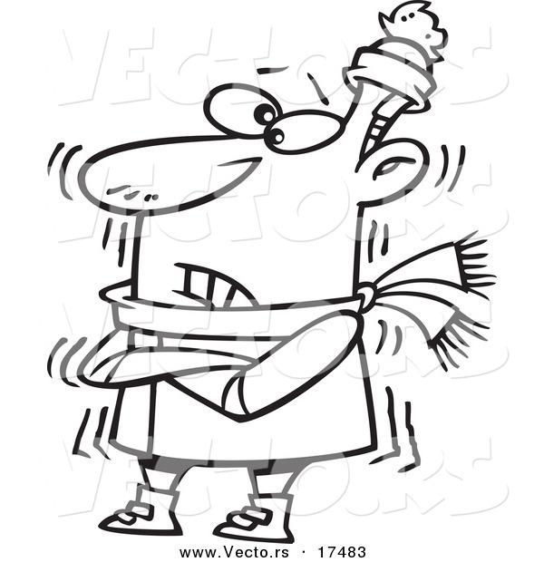
5) What happens when you are cold?

