Week 4 Quiz- Teacher Key
1. Shades can help you feel ________.
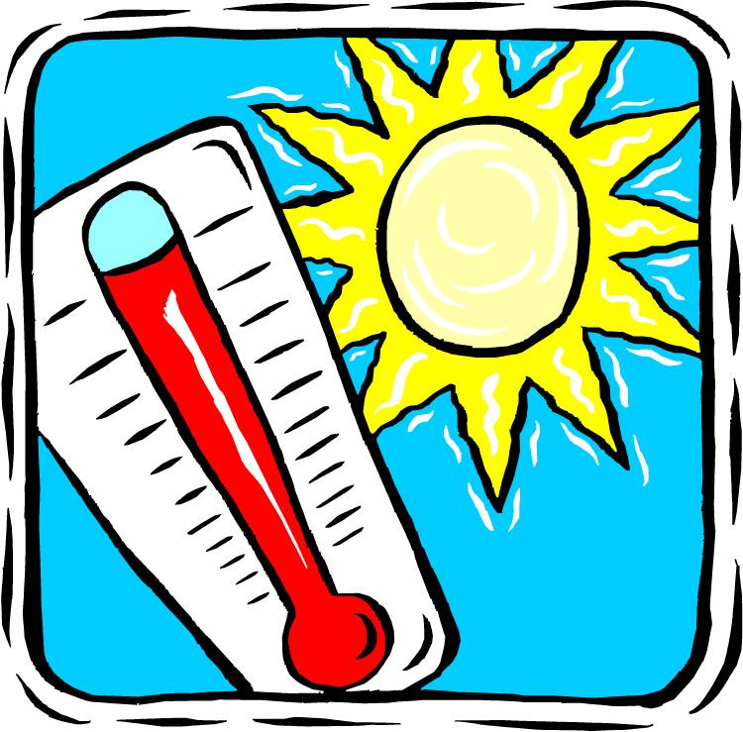
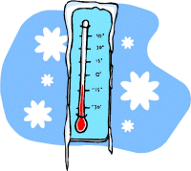
a) Hot b) cool

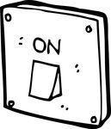
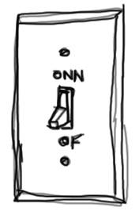
2. A shadow is a place where _________.
a) no light is shining b) light is shining

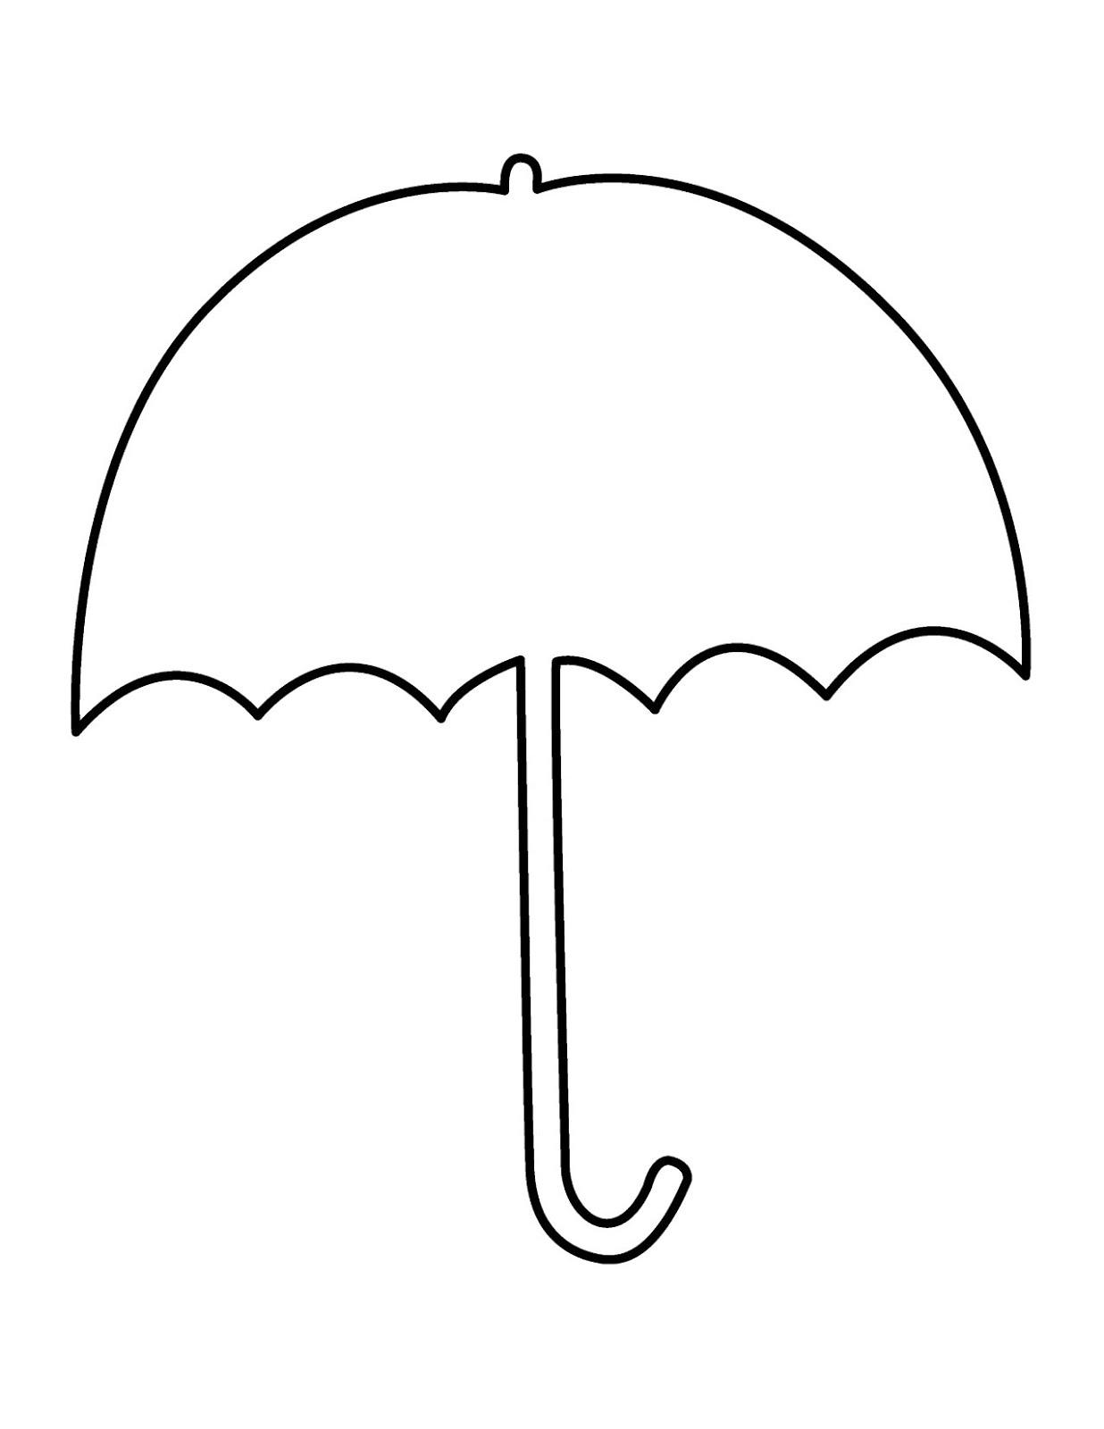
3. What can we use to make shade?

a) umbrella b) pencil

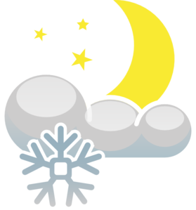
4. Shade can help protect us from _____.
a) sunlight and heat b) moonlight and snow

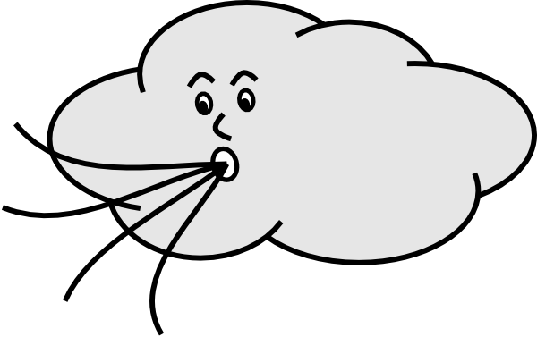
5. What makes the shade cool?
a) no light under shade b) the wind

