Name _________________
Date __________________

Week 5: How Weather and Climate Affects Us

Lab: See how floods can affect cities and homes.
(Ideal for groups of 5-6 for a classroom of 25-30 students)

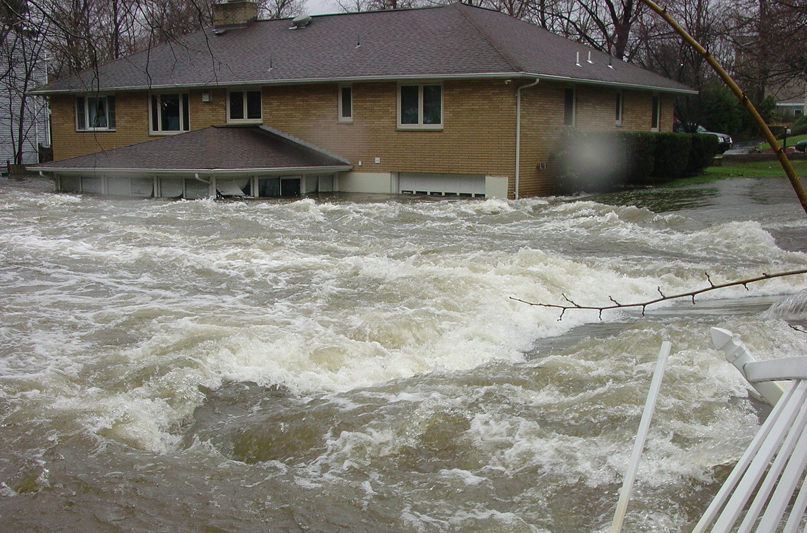
Materials:
-1 plastic container
-2 canisters play-doh
-paper cups
-bucket of water
-construction paper
-scissors
-tape
-colored pencils/markers

Procedure:
1. Trace template on construction paper 5 times. Cut, fold, and tape.
2. Place the homes on one end of the plastic container, somewhat scattered.
3. Using the canisters of play-doh, build a boundary in the middle of the plastic container, one side with houses, the other is empty. Make sure that the play-doh is firmly pressed into the bottom of the container.
4. Using the paper cups, pour in one cup of water on the empty side of the container.
5. Record if there are houses that are wet, or houses that are submerged (house including roof in under the water)
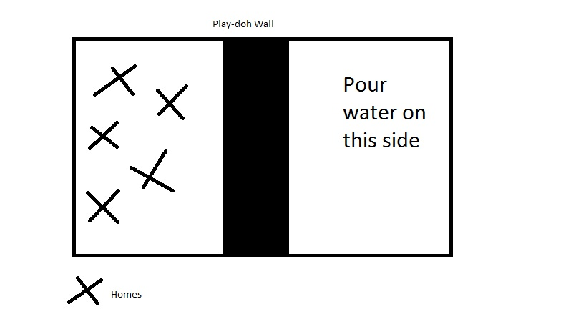
6. Repeat step 4-5 10 times.

Number of Cups of Water | Houses that are wet | Houses that are submerged
1
2
3
4
5
6
7
8
9
10

Explanation:
The houses represent a community that we live in. The play -doh wall is a representation of a levee which is like a cement wall built in order to keep water from flooding nearby homes. The water is a small-scale example of what a real flood would be like. The height of the water is known as gauges which measure how much water there is. Little floods have a high gauge number, while large floods have a lower gauge number. For example, small floods would have a number of 100-200 while large floods would have a number of 10 and under.



