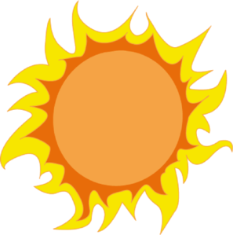
Protection From the Sun

The sun can be very powerful. If you stare at it, it can damage your eyes and blind you. It is hurts to look directly at the sun. To protect your eyes from the sun, you should wear sunglasses or a hat.
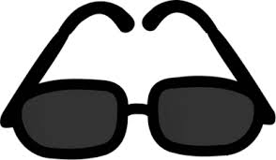

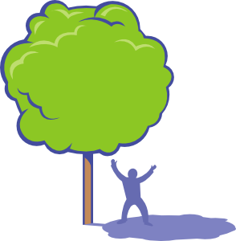
The sun may also damage your skin, such as giving you sunburns and possibly leading up to skin cancer. Protect yourself by wearing sunblock and stay in the shade if possible.

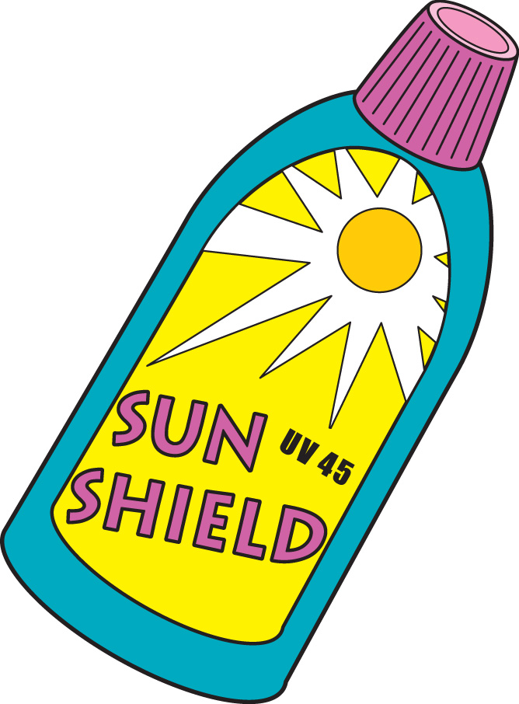

Name:__________________ Date:_________

Directions: For #1-4, circle the answer that applies best.

Does this protect your skin or eyes?
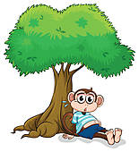
1.)

Eyes Skin

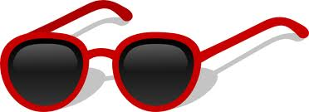
2.)

Eyes Skin
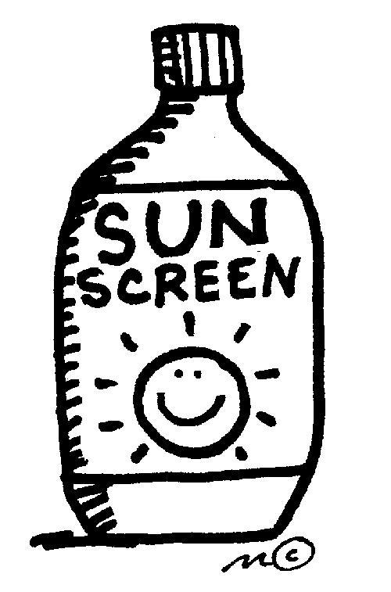

3.)
Eyes Skin

4.
Eyes Skin

5. What can happen if you stand in the sun for too long?

