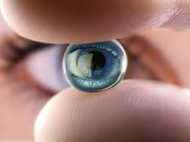
Response to the Environment Video Questions

a) What responds to external stimulus?

b) What does a stimulus cause?

c) What is an example of response?

d) How do plants respond to stimulus?

e) What is an example of external stimuli?

